***DANCIN’ FEET IN MOTION***

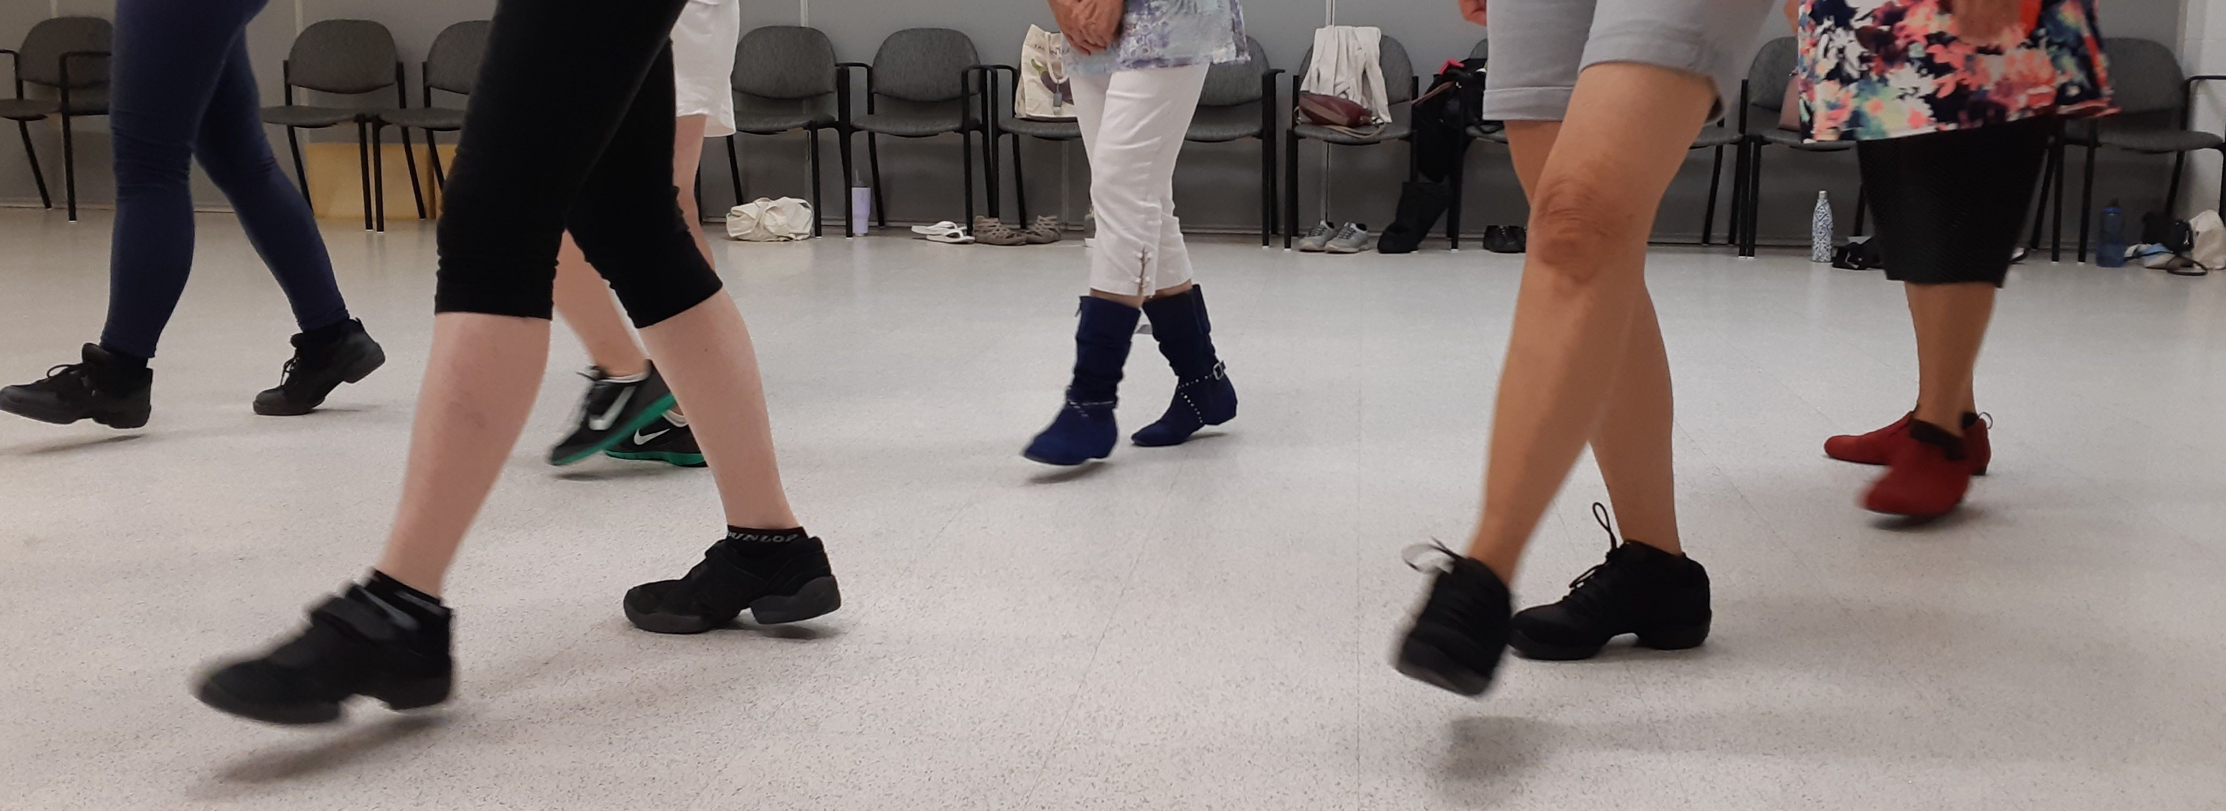

***MODERN LINE DANCE CLASSES!***



*Have FUN while getting/staying FIT!*

**ALL LESSONS HELD AT PARKSIDE CENTRE**

**140 DURHAM ST., SUDBURY (IN THE YMCA BUILDING)**

**NOT ASSOCIATED WITH THE YMCA**

**Cost is $8 per person, per lesson, pay as you go (if you don’t attend you don’t pay)**

|  |
| --- |
| **ALL OF THESE CLASSES REQUIRE PREVIOUS LINE DANCE EXPERIENCE**  **All classes will accept ages 14 years +**  **Mondays: 10:30 a.m. to 12:15 p.m. (2 yrs required) Improver Level**  **Mondays: 12:45 p.m. to 2:45 p.m. (4 yrs required) Intermediate Level**  **Mondays: 2:45 p.m. to 4:15 p.m. (9 mos. required) Beginner Level**  **Wednesdays: 5:30 p.m. to 7:00 p.m. (2 yrs required) Improver Level**  **Wednesdays: 7:00 p.m. to 8:30 p.m. (2 yrs required) Bgnr/Improver Level**  **Thursdays: 6:30 p.m. to 8:30 p.m. (1 yr required) Bgnr/Improver Level** |

**CALL OR EMAIL**

**Carol Larocque (Parkside Member) – 705-665-1399**

[**dancinfeetinmotion@gmail.com**](mailto:dancinfeetinmotion@gmail.com)

[**www.dancinfeetinmotion.ca**](http://www.dancinfeetinmotion.ca)